* Identidad de marca
* Seguridad
* Conocer a los clientes
* Profesionalismo
* Analisis FODA
* Persuasión

[COMO SER WEB DESIGN FREELANCER (Y VENDER FÁCIL) | #SemanaDaltoEmprende](https://www.youtube.com/watch?v=BvK8qTPQOKk)

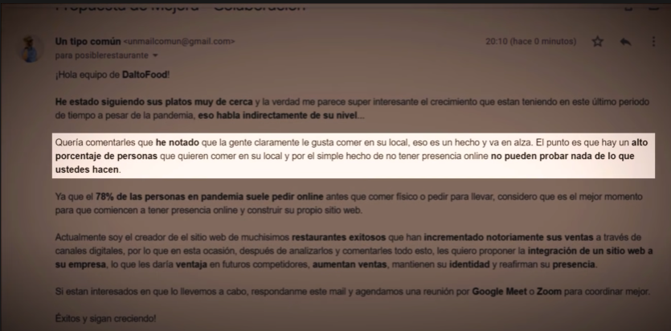

Mensaje genérico:

a

APIs:

* [API GOOGLE MAPS EN 10 LINEAS CON JAVASCRIPT](https://www.youtube.com/watch?v=HtLfFlqyiIs)

Dentistas:

**Páginas existentes:**

* <https://ortodonciaian.org/>
* <http://www.sisodental.com.ar/>
* <https://plantillashtmlgratis.com/en/todas-las-plantillas/plantilla/free-html-css-template-summer/>

**Diseños Wix:**

* <https://www.wix.com/website/templates/html/health-wellness/health>
* <https://www.wix.com/website-template/view/html/1751?originUrl=https%3A%2F%2Fwww.wix.com%2Fwebsite%2Ftemplates%2Fhtml%2Fhealth-wellness%2Fhealth&tpClick=view_button>
* <https://www.wix.com/website-template/view/html/2840?originUrl=https%3A%2F%2Fwww.wix.com%2Fwebsite%2Ftemplates%2Fhtml%2Fhealth-wellness%2Fhealth&tpClick=view_button>
* <https://www.wix.com/website-template/view/html/2088?originUrl=https%3A%2F%2Fwww.wix.com%2Fwebsite%2Ftemplates%2Fhtml%2Fhealth-wellness%2Fhealth&tpClick=view_button>.

**Elementos necesarios:**

* Servicios que ofrece
* Localización
* Contacto
* Sacar turno
* Profesionales (dentistas)

Estéticas: a